Market Segmentation for Biotech Startup

**Vitamin Deficiency Problem in India**

### Feynn Lab Project 2 by Nakul Bisen

### Github-<https://github.com/nakul2070>



**ACKNOWLEDGMENT**

I’d like to convey my deep gratitude to **Sanjay Basumatary**, who provided me the op- portunity to work on Market Segmentation. I want to thank him for his e*ff*orts, faith and patience in guiding me throughout this project work. I owe a great debt of gratitude to FeyNN Labs and all people who assisted and encouraged me in completing my project successfully. I am always grateful to my family for their selfless love, care and support. All of this would not have been possible without my father’s encouragement and financial support. At last, I would like to surrender myself before The Lord Krishna for providing me the strength, ability and opportunity to undertake this project work and turn it into a successful one.

### THANK YOU.

### Nakul Bisen

**Abstract**

Yesterday, my friend Rajesh came to meet me, he seems upset, so I asked him what is go- ing on? Is everything alright! He said Saroj’s only son died today and the Doctor said that because of vitamin deficiency. We often hear that kind of tragic story in India. Vitamin deficiency is one of the major problems in India I thought, Why government and other Bio-tech companies could not focus on this sector?

Every day, more than 6,000 children below the age of five die in India. More than half of these deaths are caused by malnutrition-mainly the lack of Vitamin A, iron, iodine, zinc, and folic acid. About 57% of preschoolers and their mothers have subclinical Vitamin A deficiency. It’s not easy to find innovative ways to reach the audience in the pharmaceu- tical sector Covid-19 eliminated face-to-face interaction and traditional marketing ways but Market segmentation and digital marketing can reach each person and we will not hear other tragic stories like Saroj.

**Contents**

1. Market Segmentation 1
   1. Target Audience 2
   2. Geographical segmentation 3
   3. Demographic segmentation 3
   4. Psychographic segmentation 4
   5. Behavioral segmentation 5
   6. Lifestyle segmentation 6
2. K-means Clustering 8
   1. How the K-means algorithm works 8
   2. Elbow Method 10
3. Biotechnology: The Industry of the Future 10
4. Our Data Interpretation 12
   1. Vitamin A dose under age 5 from 2009-2013 12
   2. K-means Algorithm on data 14
   3. Hospitals and Beds data 2017-2019 in India 16
5. Insights and Recommendations 17
6. References 18

# Market Segmentation

Market segmentation is dividing your target market into approachable segments(groups).

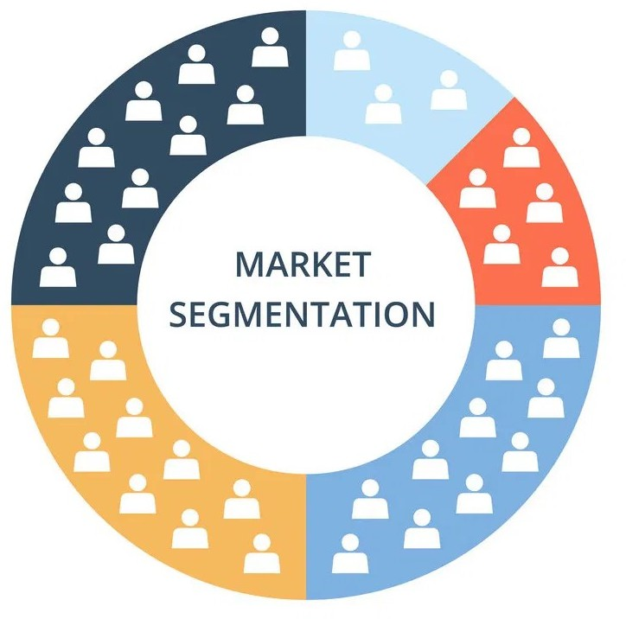

Figure 1: Market Segmentation (di*ff*erent groups of people)

Market segmentation creates **subsets of a market** based on demographics, needs, pri- orities, common interests, and other psychographic or behavioural criteria used to better understand the target audience.

By understanding your market segments, you can leverage this targeting in **product, sales, and marketing strategies**. Market segments can power your product development cycles by informing how you create product o*ff*erings for di*ff*erent segments like men vs. women or high income vs. low income. According to a study by Bain & Company, **81% of ex- ecutives** found that segmentation was crucial for growing profits.

## Target Audience

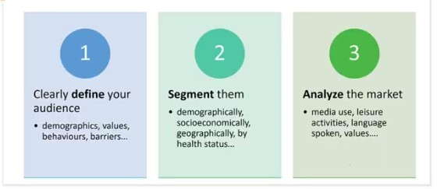

Figure 2: Choosing target audience

There are several ways to segment:

* + - Geographic
    - Demographic
    - Psychographic
    - Behavior*/* current status
    - Activities and Lifestyle

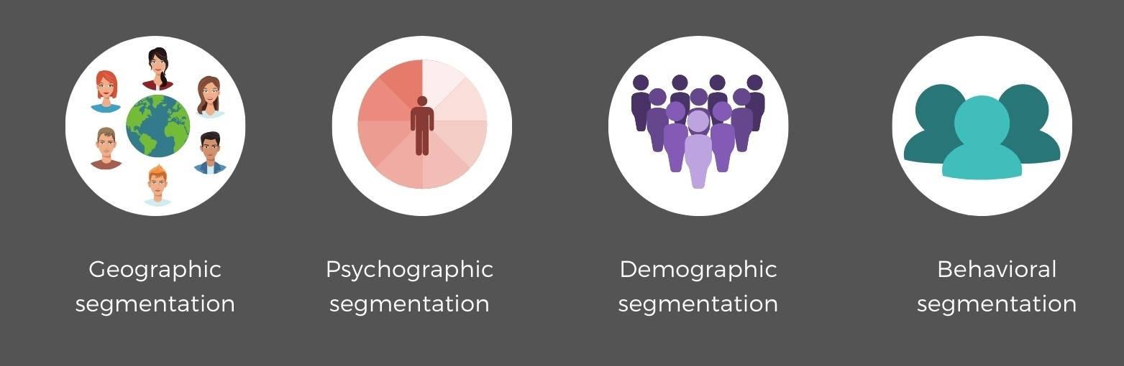

Figure 3: Types of segmenataions

## Geographical segmentation

Geographical segmentation we group people by country, state, region, urban and rural di*ff*erent type of geographical conditions.

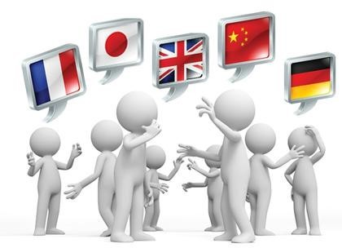

Figure 4: Geographical segmentation

## Demographic segmentation

Demographic segments includes certain types of people according to their age, gender, marital status, income, occupation and language.

Dividing the market into smaller segments, each with a common variable, allows com- panies to use their time and resources more e*ffi*ciently. They can better understand the prospective market, and use advertising personalization to ensure the needs of the tar- geted group are fulfilled. If 85% of your clients range from 20-35 years old, this is the segment you’re going to target. Spending your time and money on seniors would be a waste.

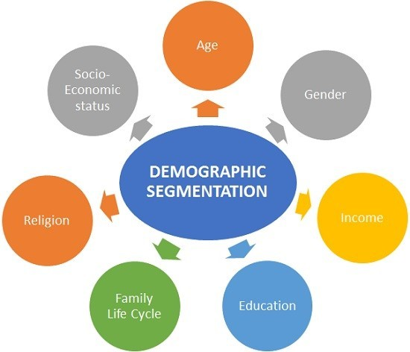

Figure 5: Types of Demographic segmentation

## Psychographic segmentation

Psychographic segmentation is defined as a market segmentation technique where groups are formed according to psychological traits that influence consumption habits drawn from people’s lifestyle and preferences.

It is mainly conducted on the basis of “how” people think and “what” do they aspire their life to be. What are their opinions about politics and entertainments ? For example, if a food delivery company identifies that its customer base has a huge segment of introverted personalities, they may want to use advertisements that depict people eating delicious food alone in the comfort of their homes.

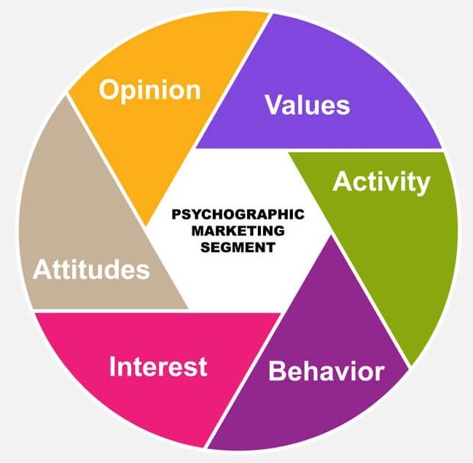

Figure 6: Types of Psychographic segmentation

## Behavioral segmentation

Behavioral segmentation is a form of marketing segmentation that divides people into di*ff*erent groups who have a specific behavioral pattern in common. Users may share the same lifecycle stage, previously purchased particular products, or have similar reactions to your messages.

If we consider **occasion based** then, this is segmentation based on specific timing which is best to deliver your marketing messages.

Utilize marketing holidays like Black Friday, Cyber Monday, or national holidays de- pending on the user’s location. Take advantage of special dates like their birthday or anniversary. Pay attention to the days of the week and time of the day that is most conve- nient for communication.

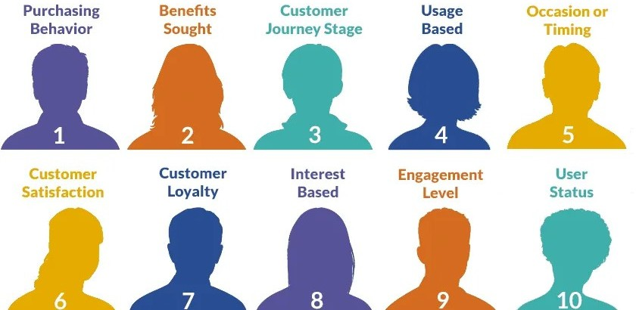

Figure 7: Types of Behavioral segmentation

## Lifestyle segmentation

We already discuss the main four type of segmentations It is just for addition information, Lifestyle segmentation is a categorization of target audiences by how they live, which includes activities like healthy eating, staying active, and participating in sports and other hobbies.Lifestyle segmentation help marketers to better understand customer needs and requirements and then take decisions of product placement in appropriate market segment. But marketers should know that the lifestyle analysis is a continuous process because consumer activities, opinions, interests and demographics changes with the time, taste and situation.

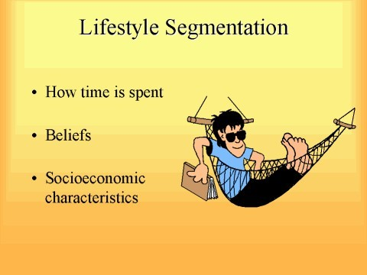

Figure 8: Lifestyle segmentation

We have to analyze each segment of the market and also include focus groups, surveys, literature reviews, consulting with marketing resources for that group.

### Things to consider:-

* + - Preferred media
    - How they communicate with each other
    - Language spoken including slang and dialects
    - Belief, attitudes, opinions about the specific health behaviour
    - Overall values
    - Don’t guess!! Especially not using stereotypes do the home work to get to know your audience

# K-means Clustering

K-means clustering is one of the simplest and popular unsupervised machine learning algorithms.A cluster refers to a collection of data points aggregated together because of certain similarities.

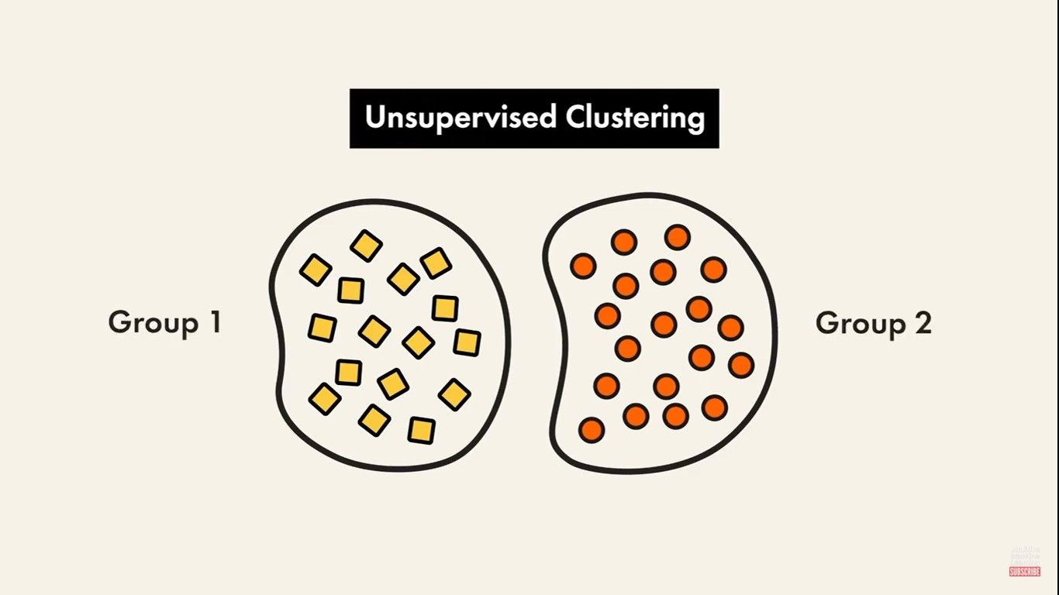We’ll define a target number k, which refers to the number of centroids you need in the dataset. A centroid is the imaginary or real location representing the center of the cluster.The ‘means’ in the K-means refers to averaging of the data; that is, finding the centroid.

Figure 9: K-means Clustering

## How the K-means algorithm works

There are major three steps:-

1. Initiate the **centroids(k)**, Figure (10)
2. Calculate distance and assign the clusters to data points, Figure (11)
3. Move the centroid(by calculating mean of cluster), Figure (12)

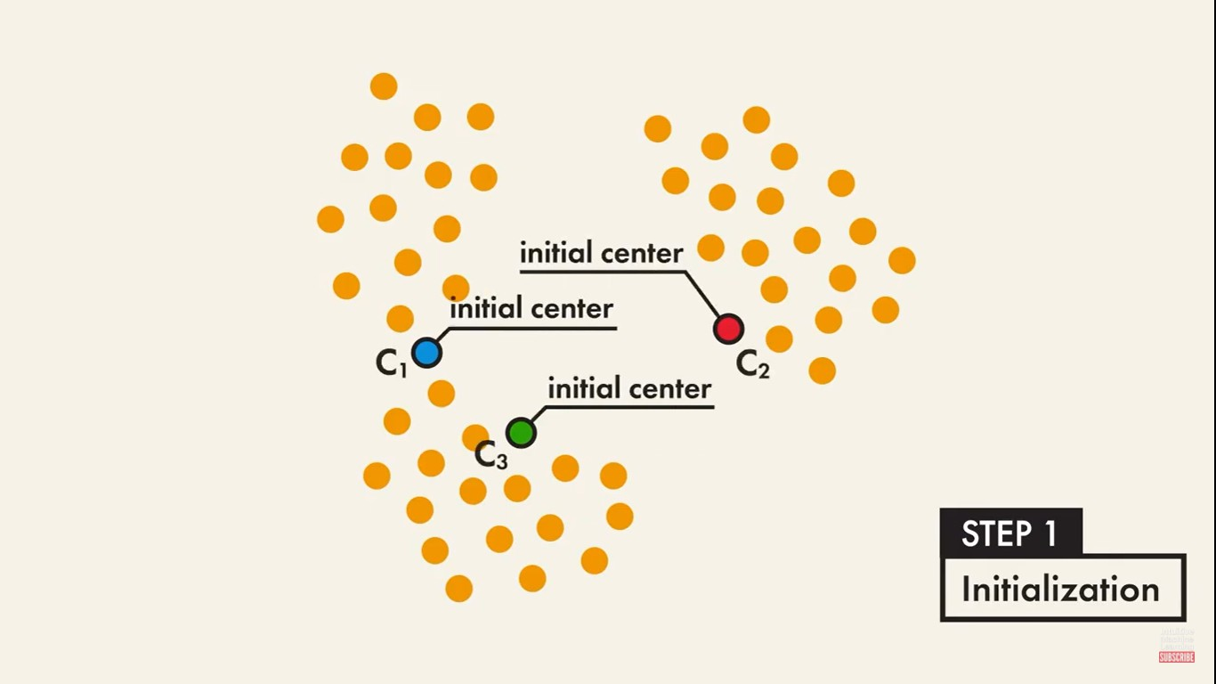

Figure 10: Step-1

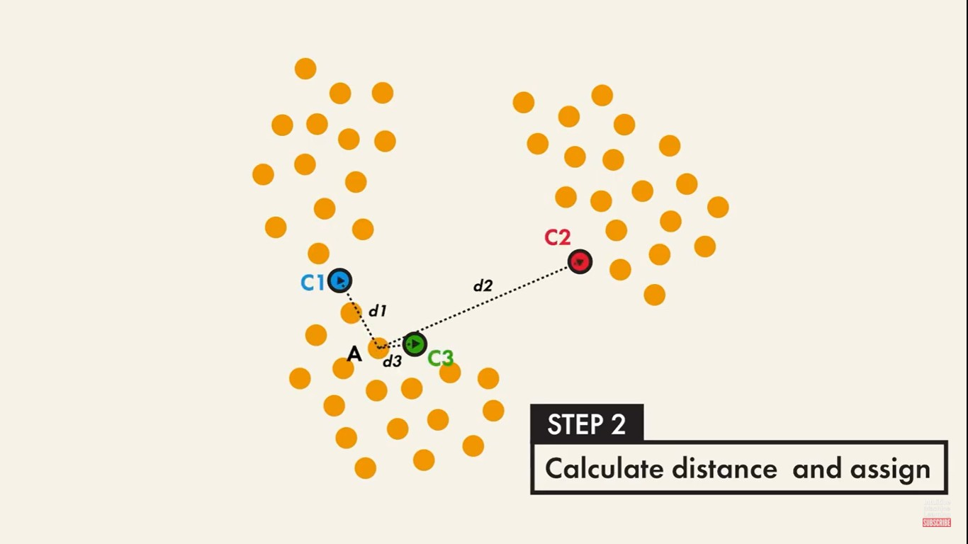

Figure 11: Step-2

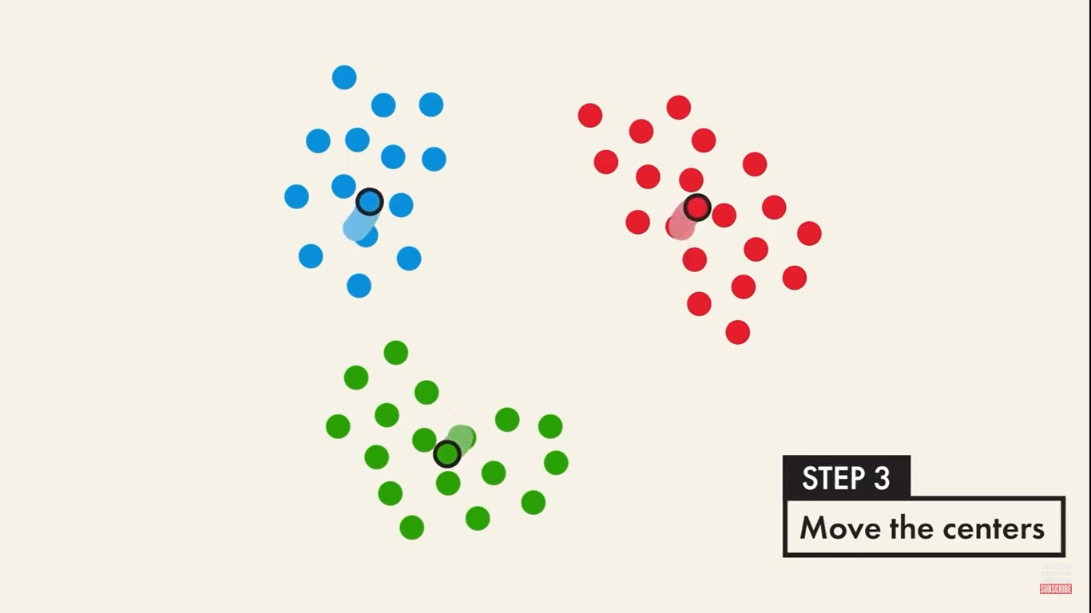

Figure 12: Step-3

## Elbow Method

A fundamental step for any unsupervised algorithm is to determine the **optimal number of clusters** into which the data may be clustered. The Elbow Method is one of the most popular methods to determine this optimal value of k.

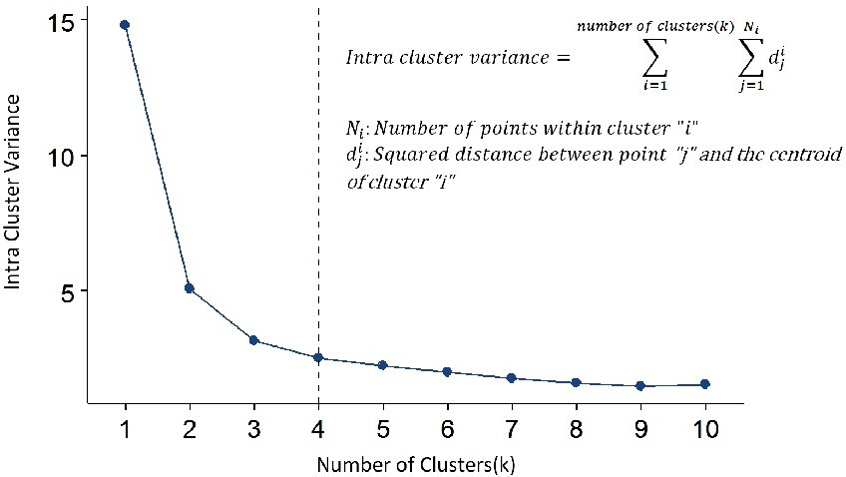

Figure 13: Elbow Method

# Biotechnology: The Industry of the Future

The biotechnology sector includes five segments that cater to di*ff*erent sectors; like, bio- pharma, bio-services, bio-agriculture, bio-industry and bio-informatics. We are partic- ularly focus on Bio-pharam. Because It has maximum growth potential and maximum percentage share 64% in Biotechnology. and bio-informatics has only 1% share in the bio-tech segment.

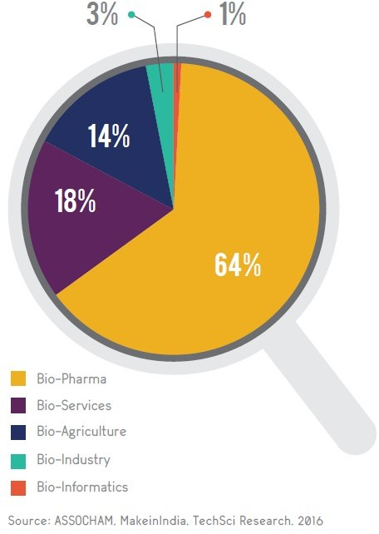

Figure 14: Percentage Share of Biotechnology Segments

# Our Data Interpretation

## Vitamin A dose under age 5 from 2009-2013

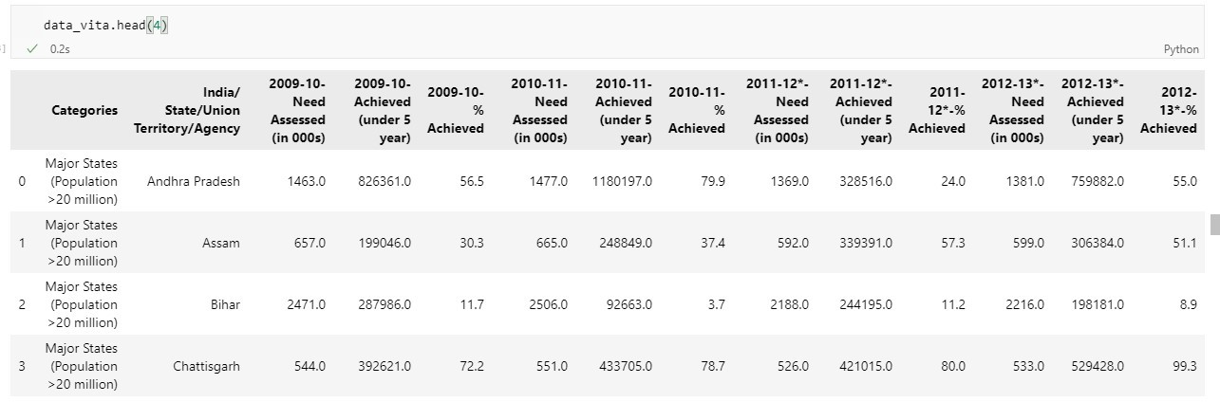

Figure 15: Vitamin A dose data of India (2009-2013)

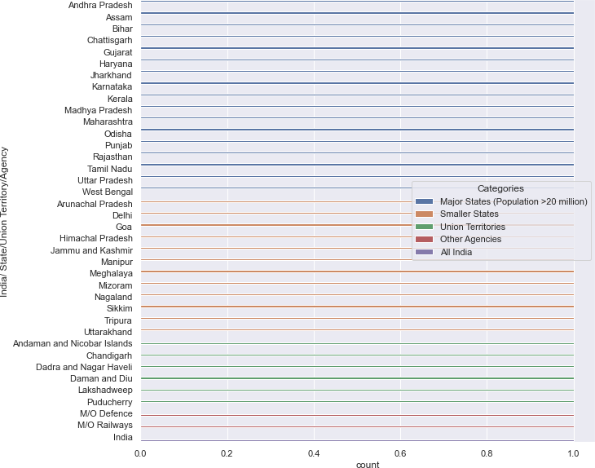

Figure 16: Vitamin A dose in states of India (2009-2013)

**Geographical** segmentation for the vitamin A dose to children under age 5 It include all the states of India, which means people are aware about the vitamin A deficiency in India and children’s parents are also concern about these kind of health issues.

It’s a good thing for any bio-tech start-up, we didn’t have to encourage people to take doses they eventually come to us and we can start our business in any state of India Because data shows that people are aware of doses for their children in every state of India Blue lines in this plot show the population greater than 20 million in states of India.

If we talk about state Gujrat and Tamilnadu they have very good amount of Achieved dose rate from 2009-13. It is a good opportunity for any bio-tech startup in both state Gu- jrat and Tamilnadu because there are people already aware they are giving their children the proper doses of vitamin A. in these years.



Figure 17

Below plot shows vitamin A dose percentage Achieved of successive 3 years from 2009-2013.

We see that maximum dose in Gujarat then Tamilnadu and other states follow, also almost every state has increases the dose per years, some state could not increases the dose like Nagaland, Delhi and Manipur etc.

Minimum dose states are Bihar, Delhi and Manipur, If bio-tech startup focus on Vi- tamin A dose then above data is very useful, we can focus on Bihar as it has maximum population and yet minimum dose of vitamin A, It has a good market.

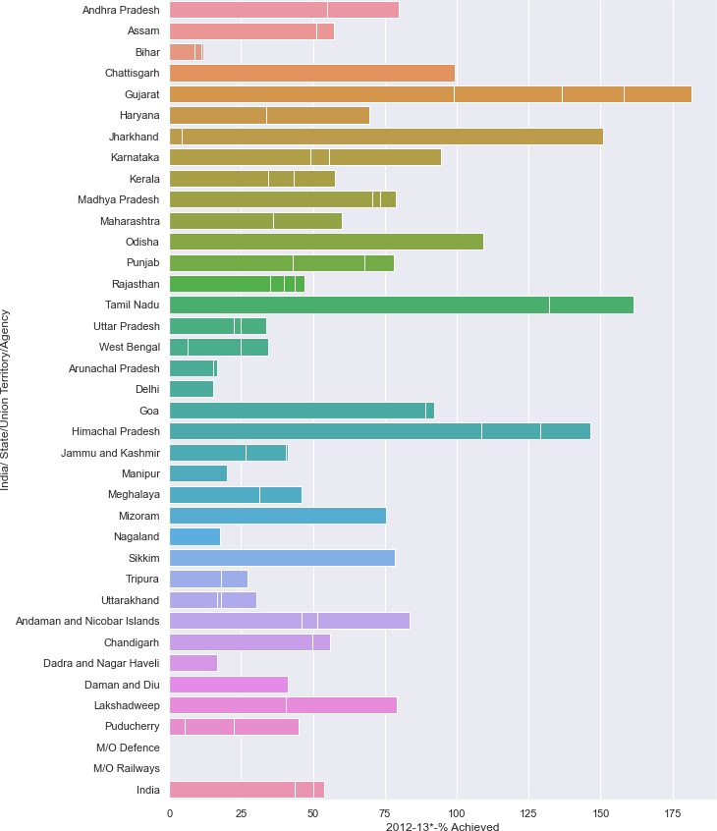

Figure 18: Vitamin A dose 2009-13-% Achieved

## K-means Algorithm on data

First we are going to find optimal value of k for data, which is k*=*2 as we see in the figure

(19) by using Elbow method.

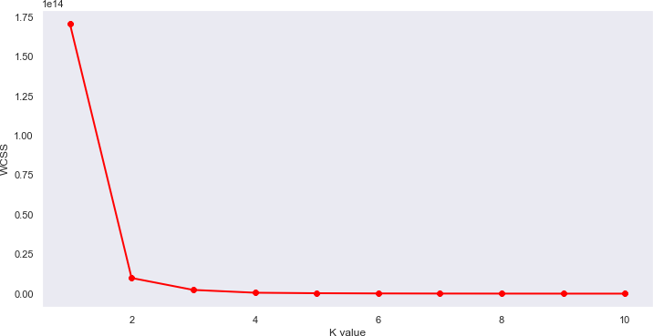

Figure 19: Optimal value of k for 2009-10-Achieved

We apply k-means algorithm to our data. As we see I select two columns for this are 2009-10-Need Assessed (in 000s) and 2009-10-Achieved (under 5 year).

What we see in the clusters is that most of data are in purple cluster means are are similar kind of data and only one data entry in the other cluster very interesting!! in figure (20)

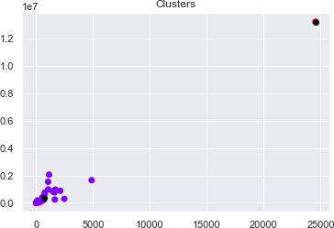

Figure 20: k-means clusters

## Hospitals and Beds data 2017-2019 in India

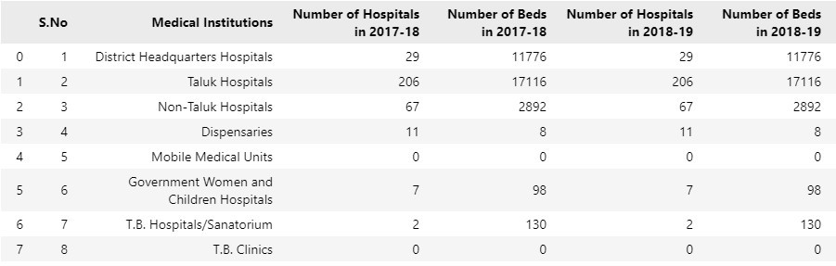

Figure 21: Preview of data

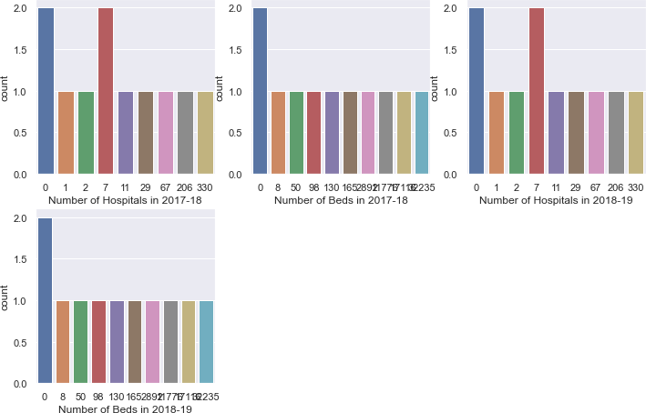

Figure 22: Availability of beds in hospital from 2017-2018

If we see care fully on these plot we understand that from 2017 to 2019 the availability of hospital as well as beds in hospitals both are same means no new hospital is open in these years.

# Insights and Recommendations

* The biotech industry in India is growing one. More start-ups are joining and ex- panding the share of output for the industry.
* Market segmentation is playing a very important role in the Biotech industry, For the growth and understanding of an audience.
* In this Project, we thoroughly understand the Market segmentation and its four types also understand the k-means unsupervised algorithm and elbow method.
* We understand the Vitamin A dose in India from 2009-13 by using Data visualiza- tion techniques. Also time to time we provide thoughts how these plots and data are useful in making a bio-tech startup.
* We also explore the data of hospitals and availability of beds in these hospitals in India from 2017-2019.

# References

1. [Rural-health-statistics-2019](https://data.gov.in/catalog/rural-health-statistics-2019?filter)
2. [vitamin](https://data.gov.in/search/site?query=vitamin)
3. [IBEF Research](https://www.ibef.org/)
4. [Market segmentation](https://www.slideshare.net/bryanoculam/slide-share-25435148)
5. [Intuitive Machine Learning](https://www.youtube.com/watch?v=mEGYznC6F9s&list=PLkguTFqZ9THFtRU9V-8ocNyG8iyw4RXBe&index=3)
6. [GitHub Project Link](https://github.com/HotuRam/FeyNN-Labs-Project-2)